[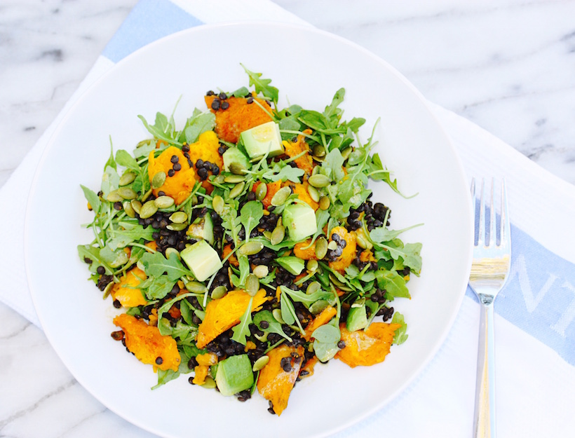](http://goop.com/recipes/braised-lentil-salad/)

**TIP**

**Pack this for lunch with dressing on the side so the arugula doesn’t get soggy.**

**BRAISED LENTIL SALAD WITH ROASTED KABOCHA, ARUGULA & AVOCADO**



**GOOP**

*This is the perfect way to use leftover braised lentils and roasted squash. Feel free to add whatever seeds or vegetables you have on hand.*

**SERVES 1**

½ cup braised lentils

1 large handful arugula

flesh from ¼ roasted kabocha squash

½ an avocado, diced or sliced

handful toasted pumpkin seeds

pinch sea salt

for the dressing:

1 teaspoon Dijon

2 tablespoons red wine vinegar

¼ cup olive oil

salt and pepper

1. To make the dressing, whisk together Dijon mustard, red wine vinegar, and salt and pepper. In a steady stream, whisk in the olive oil.

2. Combine lentils, arugula, squash, and avocado in a large bowl.

3. Sprinkle with toasted pumpkin seeds and sea salt, and serve with dressing.